1. Overview
You've completed two game prototypes: the 3D Roll-a-Ball game and the 2D Sprite Flight game. Your games are playable and fun, but they lack a clear identity: a distinctive theme, narrative, or cohesive art direction that makes them memorable.
Your current game might be a simple setup where a sphere rolls around to collect rotating cubes while evading enemies, or a 2D character that flies around to avoid obstacles. These solid gameplay foundations could become almost anything with the right design vision.
For example, your Roll-a-Ball game could become one of the following:
- A jungle adventure where a rolling monkey collects fruit while avoiding wild predators
- A sci-fi thriller where an alien sphere gathers resources and dodges robotic enemies on a distant planet
- An underwater exploration where a bubble collects pearls while evading jellyfish
As a reminder, check out a couple of the different directions that learners have taken their roll-a-ball games.
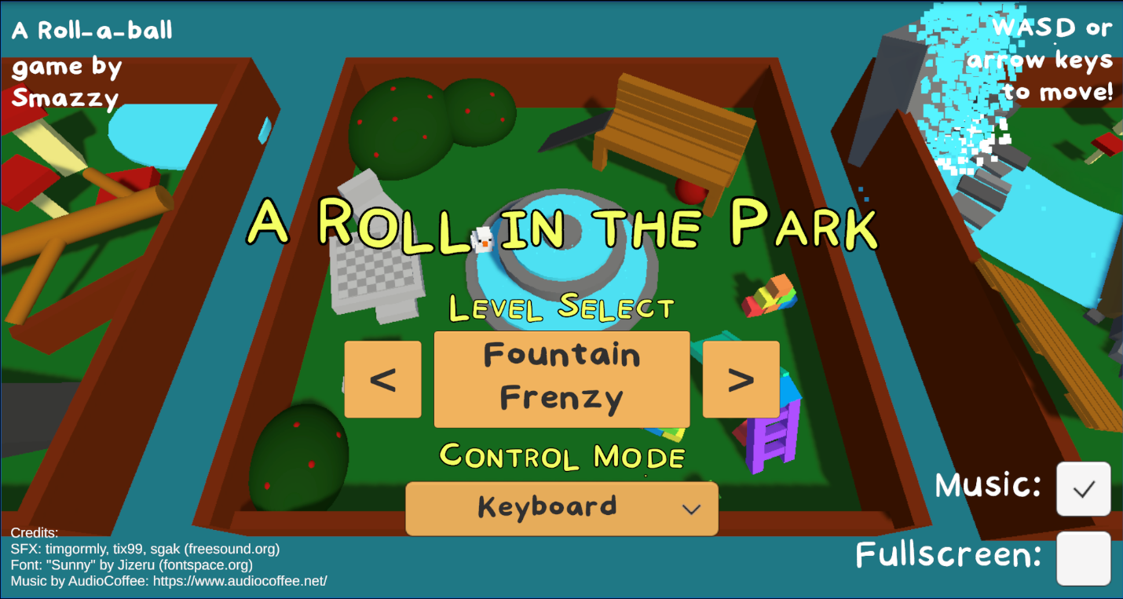
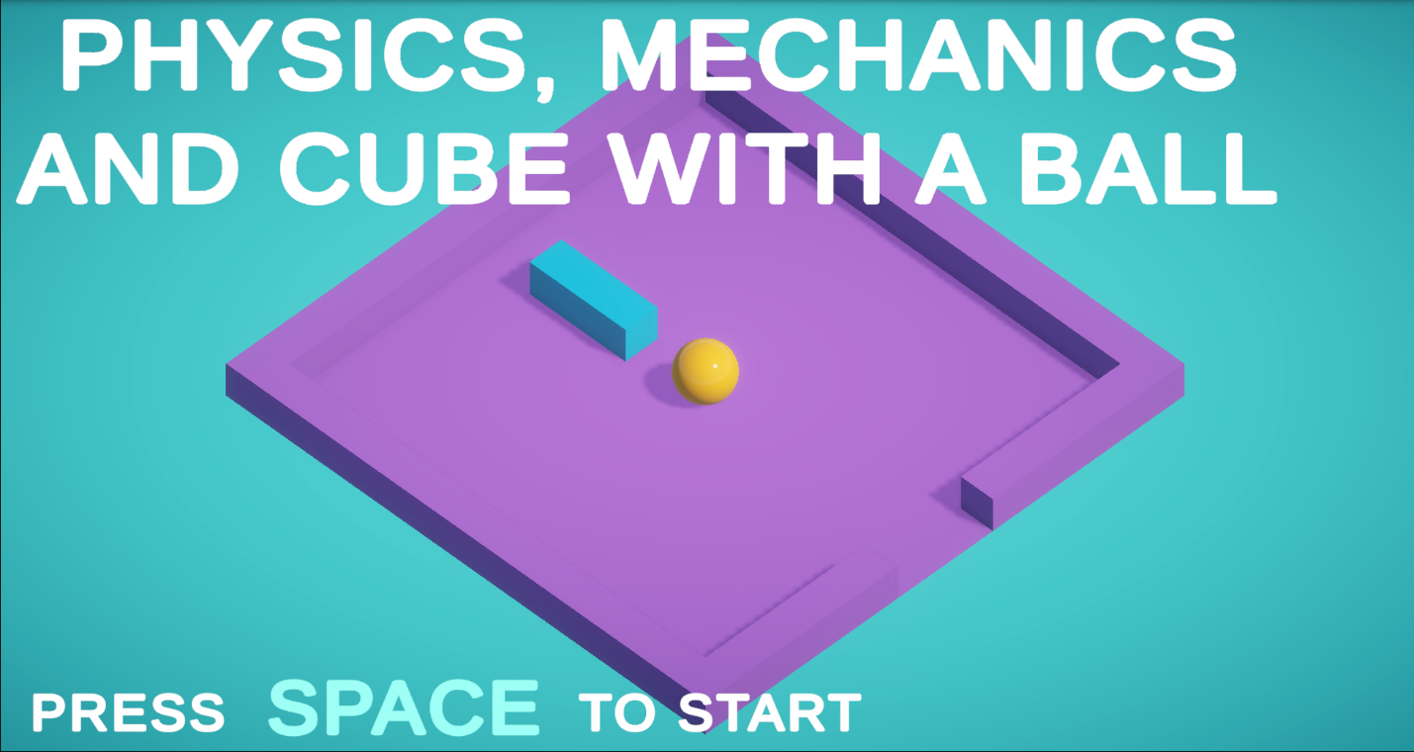
If you’re interested in developing your 2D game, it could become one of the following:
- A dragon hatchling learning to fly through a magical forest
- A paper airplane navigating an office building
- A fish in a pond avoiding enemy fish
- A top-down dungeon adventure where your character is avoiding ghosts
Look at the examples below, which began from the same triangle-avoiding-hexagon prototype.

Play Video
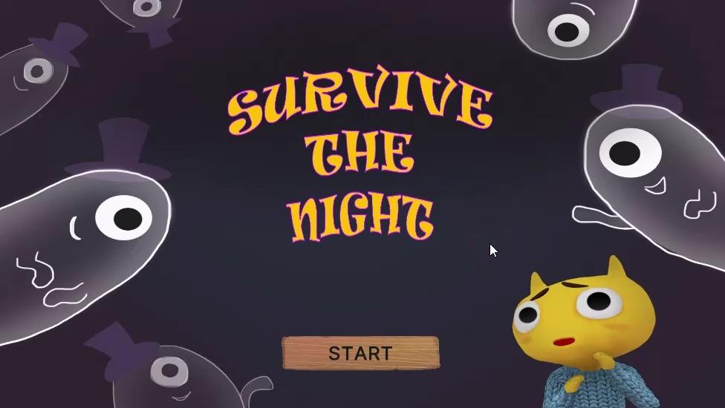
Your task now is to give your game an identity that sets it apart. To achieve this, you'll begin work on a game design document (GDD): a blueprint that details your design decisions and guides your development.
2. A note about this process
In professional game development, you might write a GDD before building anything, or you might prototype first and formalize later. In this pathway, you've taken the prototype-first approach. You're working with a specific prototype you've already built (Roll-a-Ball or Sprite Flight), and are building a GDD around one, or both, of those.
This creates an interesting constraint: your existing prototype establishes the core gameplay parameters. Your player character already moves in a certain way, you've already established basic mechanics like collection or obstacle avoidance, and you have working collision and win/lose conditions.
Why is this valuable?
- Creative constraints often spark better creativity: Having boundaries (your existing prototype) helps you focus on adding a meaningful theme, narrative, and polish rather than getting lost in endless possibilities.
- Scope management: Building on a proven prototype prevents scope creep. You're refining an existing foundation rather than starting from scratch.
- Real-world skill: Many professional designers inherit existing prototypes or mechanics and must build compelling experiences around established systems.
This approach also helps prevent one of the biggest pitfalls in game development: ambitious designs that never get finished. By building your GDD around a working prototype, you're ensuring your vision is grounded in reality.
Watch the video below to hear experienced creators talk about scoping their projects.
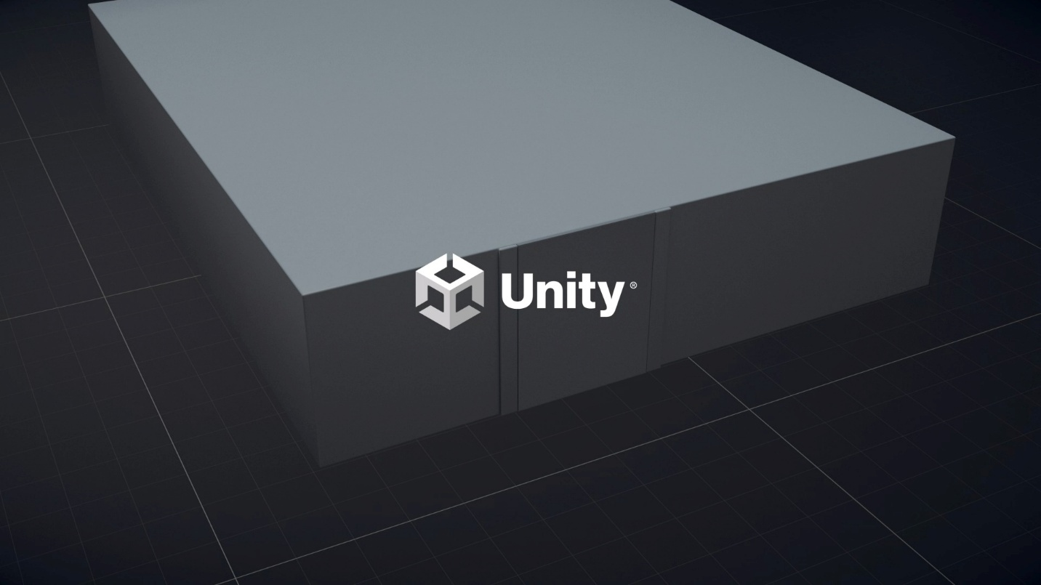
3. Choose your project focus
For this tutorial, and the remainder of the learning pathway, you can do any of the following three options:
- Option 1: Create a GDD that builds upon your 3D Roll-a-Ball game
- Option 2: Create a GDD that builds upon your 2D Sprite Flight game
- Option 3: Create GDDs for both projects (recommended if you have time, since you'll finish with multiple portfolio pieces and solidify your 3D and 2D skills)
Throughout this tutorial, examples will reference both 3D and 2D possibilities.
Decide now which option you'll pursue. And don’t worry about missing out — if you choose only one project now, you can always decide to do the second one at a later time.
Mark step complete
4. What is a game design document?
A game design document (GDD) is a living document that captures your game's design: its goals, mechanics, feel, visual direction, and development plan. It serves multiple purposes:
- Communication tool: Helps you explain your vision to teammates, playtesters, or portfolio reviewers
- Reference document: Keeps track of design decisions as your project evolves
- Problem-solving aid: Writing out your design often reveals gaps or inconsistencies you need to address
Below are a couple of screenshots from game design documents developed by the Unity team for the creation of example learning projects.
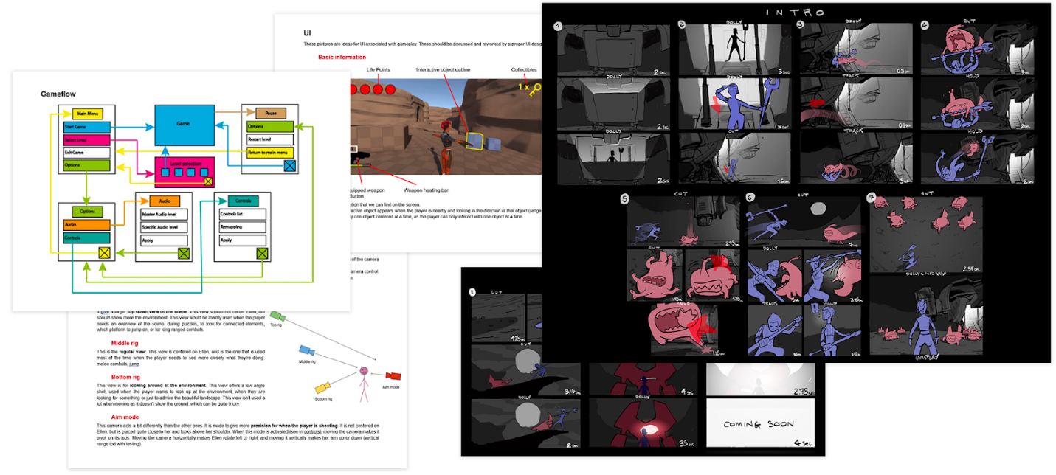
Professional GDDs can be very long and include sections like the following:
- Target audience analysis and player personas
- Competitive analysis and market positioning
- Technical specifications and engine requirements
- Level-by-level design documentation with detailed layouts
- Character backstories and complete dialogue trees
- Audio design and music direction
- Monetization strategy and LiveOps plans (for free-to-play games)
- Marketing hooks and unique selling points (USPs)
- Production timeline with team roles and milestones
For this learning project, we're focusing on core design elements that help you think clearly about gameplay. As you gain experience, you can expand your GDD(s) to include these additional elements.
A real-world example: Stacking (Double Fine)
If you want to see what a professional, full-scale GDD looks like, take a look at the original design document for Stacking, written by Lee Petty at Double Fine Productions.
This GDD is much more detailed than the one you’ll create in this learning project, but it’s useful to skim over and notice how it includes the following:
- A clear game overview and design goals
- Detailed gameplay systems and mechanics
- World, character, and story descriptions
- Extensive sections on UI, camera, audio, and cinematics
You don’t need to read every page, but note how the document is organized and how gameplay concepts are explained in writing and through diagrams.
Check out the full document
Your GDD template
For this tutorial, we've created a simplified GDD template focused on the design fundamentals you learned in the previous tutorials on game design, game genres, and game platforms. The template includes the following sections:
- Introduction: Name, title, one-sentence pitch, verbs
- Core Design Elements: Player goals, rules & mechanics, difficulty, core loop, feedback
- Art & Visuals:, Unifying colors, inspiration
- Future Features: Stretch goals and other considerations
- Optional section: Genre, target audience, platform, monetization
Below are two pages for the example 3D game you’ll see throughout the pathway.
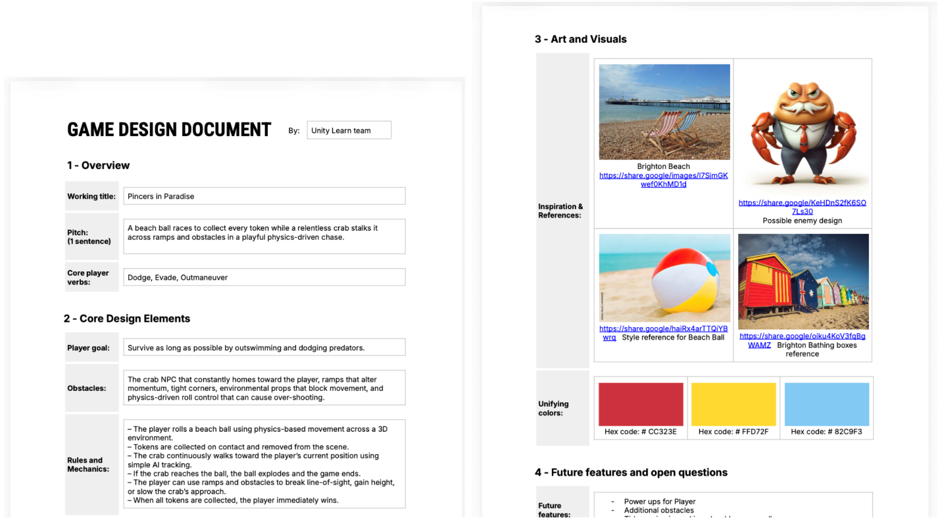
Open the GDD template
Google Docs:
- Open the GDD template and make your own copy
Microsoft Word:
- Download the Microsoft Word version
Mark step complete
5. Gather inspiration
Before diving into your GDD, you may want to explore inspiration for a unique theme. You could stick with a 3D ball running away from rectangular prisms (as in Roll-a-ball) or a triangular ship avoiding hexagons (as in Sprite Flight), but coming up with a unique theme will help your game have a more personal feel, and maybe inspire ideas for new mechanics.
Inspiration from the asset library
We've provided an asset library with options for player characters, pickups, environments, and enemies, which could spark some ideas.
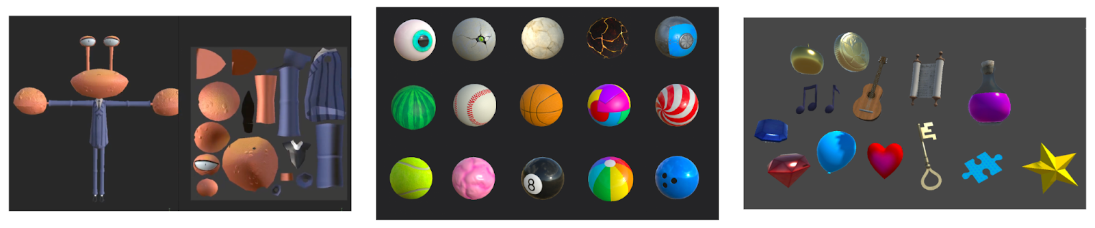
To use the asset library, follow these instructions:
1. Download the asset library Unity package.
2. Unzip and import into your Unity project.
3. Browse the Prefabs folder for characters, pickups, and enemies.
4. Browse Materials > Materials_RepeatingPatterns for environment themes.
5. Brainstorm ideas for the player character and the obstacles or enemies in its way.
Below are a couple of examples:
- "A beach ball is trying to collect seashells while avoiding a crab"
- "A dragon hatchling is trying to avoid storm clouds"
Inspiration from the Asset Store
Unity and other Unity Asset Store creators provide many free, ready-to-use assets for prototypes and learning projects.
You can use them directly in your game or browse them to spark ideas for characters, mechanics, and themes.
Seeing what’s available can help you decide what kind of game to make.
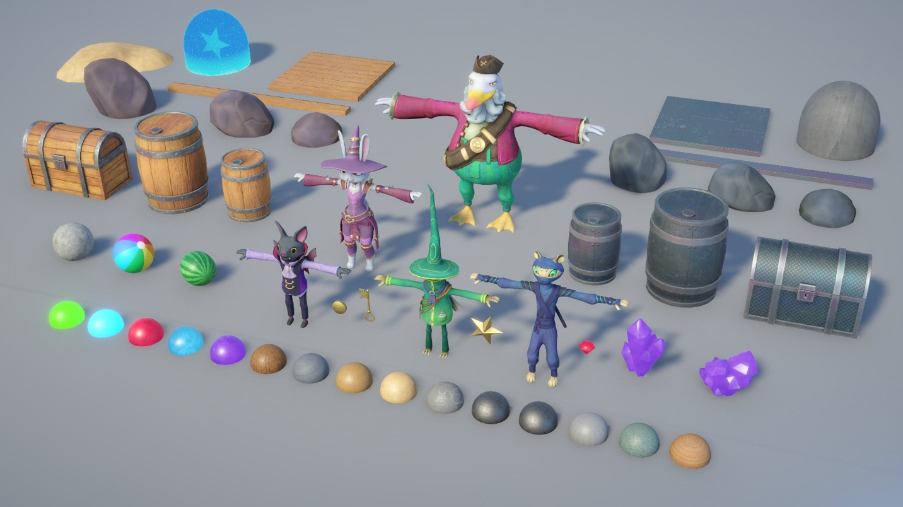
To explore free assets in the Unity Asset Store for inspiration, follow these steps:
1. Open the Unity Asset Store in your browser.
2. Search for free assets or filter by Price > Free.
3. Check out the Stylized Character Starter Pack and download it if you want playable characters to prototype with.
4. Browse other free packs (characters, environments, props, VFX, UI) made by Unity and other Unity Asset Store creators.
5. As you explore, note ideas or themes that interest you. For example:
- “A ninja sneaking through crystal caves collecting gems”
- “A pirate captain hopping between islands to find treasure”
- “A wizard solving puzzles in a magical forest”
Inspiration from other games
Look at games with similar core loops to yours. Notice their themes and the impact those themes have on gameplay mechanics. Also see if you can spot what the player's goals and challenges are in a variety of themes.
3D Roll-a-Ball style games
Super Monkey Ball
- Core loop: Navigate → Collect → Reach goal → Repeat
- Theme: Colorful, playful monkey inside a ball
- Challenge: Narrow platforms, moving obstacles, time limits
Play
Mute
Remaining Time -0:13
1x
Playback Rate
Fullscreen
Marble It Up!
- Core loop: Roll → Jump → Collect → Race to finish
- Theme: Abstract, futuristic racecourse
- Challenge: Precision platforming, speed optimization
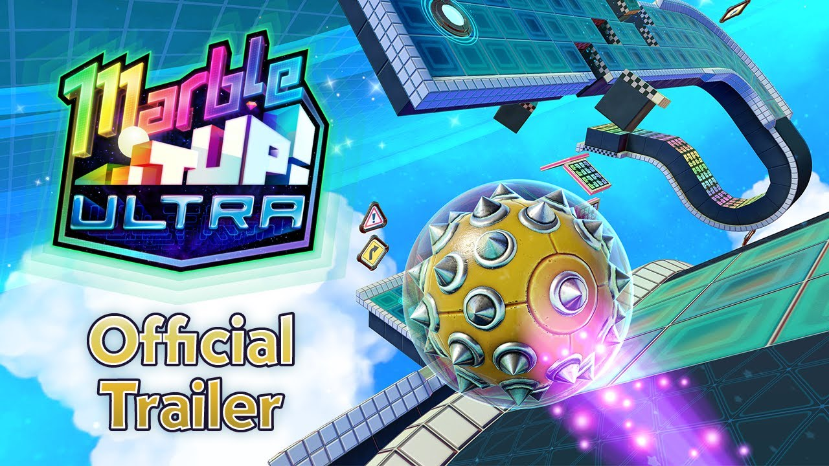
2D Sprite Flight style games
Bit Blaster XL
- Core loop: Fly → Dodge → Shoot → Survive → Repeat
- Theme: Retro arcade space shooter with bright visuals
- Challenge: Increasing enemy density, bullet patterns, confined screen space requiring constant movement
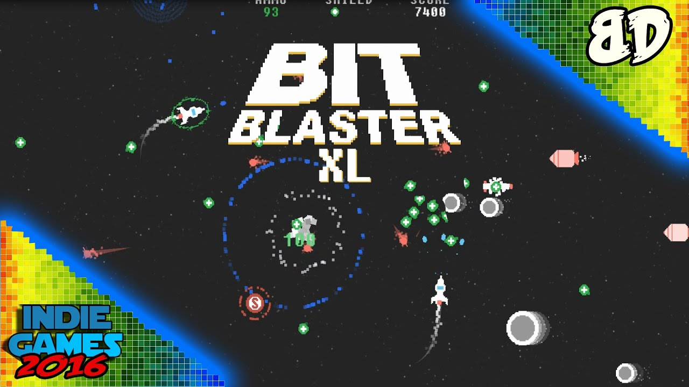
Beat Hazard 3
- Core loop: Shoot → Dodge enemy waves → Power up with music → Survive → Repeat
- Theme: Music-driven, twin-stick shooter where your music collection becomes a playable galaxy
- Challenge: Enemy hordes and bullet patterns that ebb and flow dynamically based on the intensity of your music; weapons power up during musical peaks

Other games to explore for inspiration
Subway Surfers (3D endless runner)
- Core loop: Run → Dodge → Collect coins → Power up → Repeat
- Theme: Graffiti artist escaping from inspector
- Challenge: Increasing speed, obstacles, train dodging
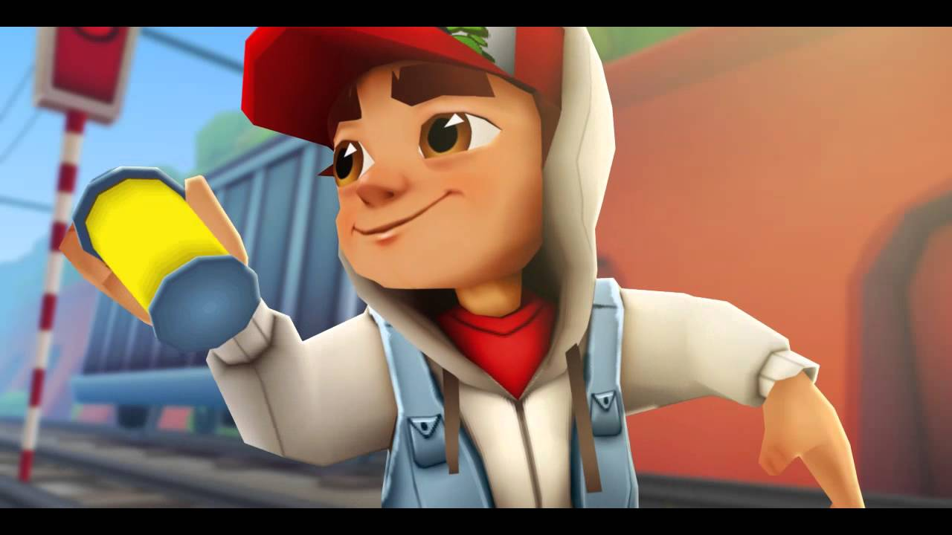
Crossy Road (3D but simple arcade style)
- Core loop: Hop → Cross → Avoid obstacles → Repeat
- Theme: Blocky animals crossing roads and rivers
- Challenge: Traffic patterns, timing, endless progression
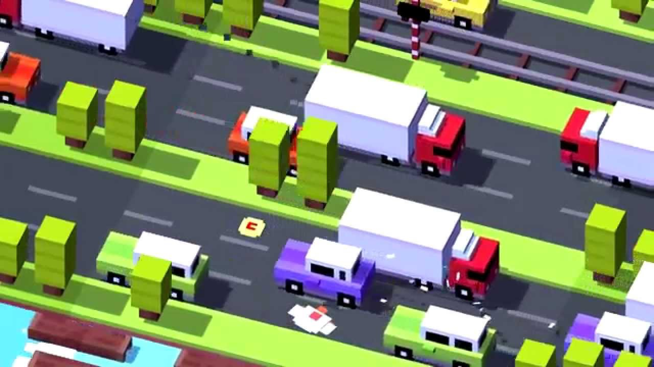
Reflection
After watching these trailers, reflect on the following:
- How does the theme change the feel of similar mechanics?
- How does the theme allow for unique challenges?
- What visual and audio feedback makes the game satisfying?
Mark step complete
6. Complete the Overview section
Now you’ll begin filling out your GDD. Start with the Overview section, which provides essential context about your game.
Your name
To do
Add your name to the document header.
Working title
A working title is a preliminary name for your game. It can be the following:
- Descriptive: "Beach Ball Escape," "Dragon Flight Adventure"
- Evocative: "Tidal Dash," "Ember's Flight"
- A code name: "Project Shoreline," "Operation Wingbeat"
This isn't your final title, so it's fine to change it as your vision evolves.
To do
Fill out the Working Title section now.
One-sentence pitch
This is a single sentence that captures your game's core experience.
Formula
"A [player character] [verb] to [goal] while [main challenge]."
Examples
- "An adventurous beach ball rolls across a tropical island to collect seashells while evading a cranky crab."
- "A young dragon learns to fly through an enchanted forest, collecting magic crystals while dodging storm clouds."
- "A space probe navigates an asteroid field to gather data samples while avoiding collisions."
Remember, this is just an idea right now. You can always change it later.
To do
Fill out the One-Sentence Pitch section now.
Mark step complete
7. Next steps
You've completed the first section of one or both of your game design documents.
As you learn about game design, genres, and platforms in the next tutorials, you’ll continue to fill out additional sections of your GDD.

